C:\Program Files\Microsoft Office\MEDIA\CAGCAT10\j0293236.wmf

**ACCESSIBLE INFORMATION STANDARD**

Says that people who have a disability, impairment or sensory loss should be given information they can easily read or understand

**Please inform any of the Team if you need us to communicate with you in a particular way**

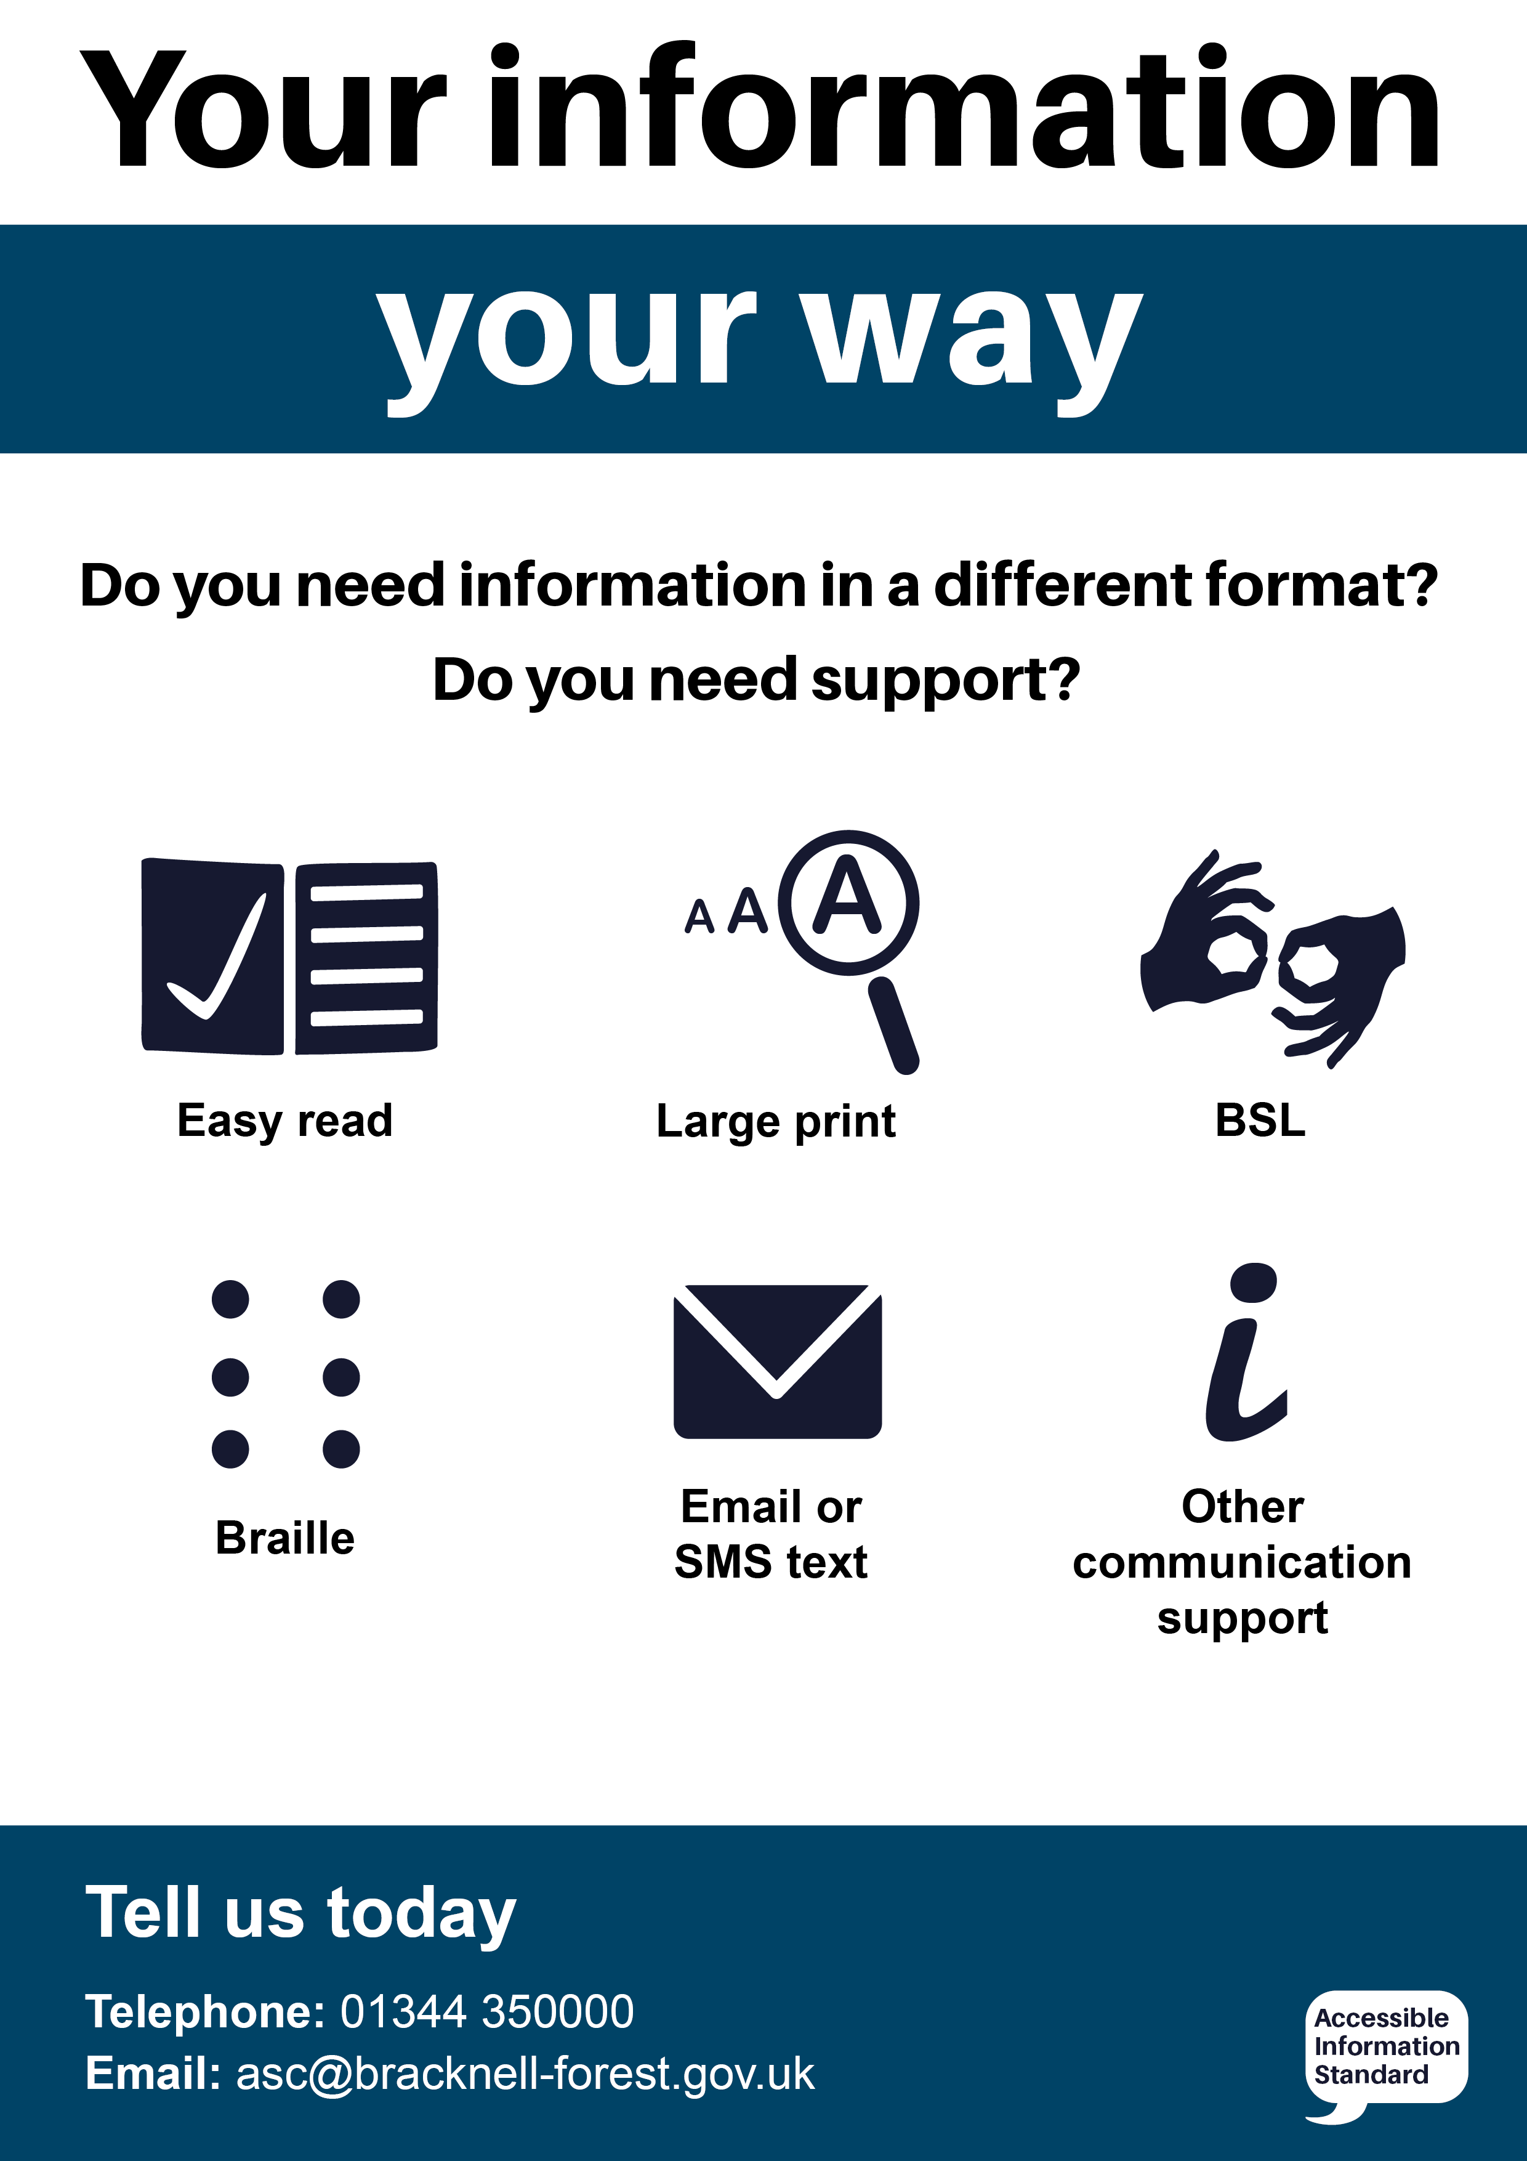

Please help us to make sure that we get things right for you by recording your accessibility requirements and information needs alongside your other details. You can call **0161 426 5850** Or email [**bramhallhc.practice@nhs.net**](mailto:bramhallhc.practice@nhs.net)

For more information visit [www.england.nhs.uk/accessibleinfo](http://www.england.nhs.uk/accessibleinfo)